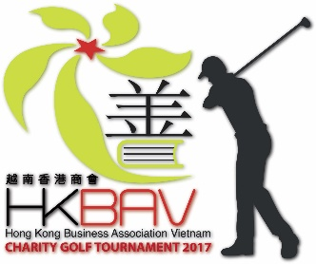

HKBAV – TUNG SHING GROUP CHARITY GOLF TOURNAMENT
2017 Award Ceremony Dinner
A HKBAV Charity Initiative
Registration Form
Song Be Golf Course, 77 Binh Duong Boulevard, Lai Thieu, Thuan An, Binh Duong Province, Vietnam
Friday, November 10th, 2017 @ Cocktail 5.30pm – Dinner 7pm
Entry fees: VND1.5mil/pax for HKBAV member and non-member.
- Welcome drinks & appetizers before dinner

Please fax Entry Form to HKBAV (028) 3520 8668 or Email to hcmc@hkbav.org

HKBAV member Non-member
Full name: Company name:

Phone: Email:
HKBAV member Non-member
Full name: Company name:

Phone: Email:
HKBAV member Non-member
Full name: Company name:

Phone: Email:

Special Notes: _____________________________________________________________________

_________________________________________________________________________________

**To guarantee your participant, completed Entry Form must be followed by full payment no later than November 01st, 5:00pm. Payment can be made by cash or TT funds to:

Account name: Hong Kong Business Association Vietnam
Account number: 9927 8704 066 (VND)
Bank Name: Standard Chartered Bank (Vietnam) Ltd
SWIFT code: SCBLVNVX
Bank address: 37 Ton Duc Thang, Ben Nghe Ward, District 1, HCMC, Vietnam
Narrative: please note “HKBAV Award Ceremony Dinner 2017”

**Cancellations received after the entry deadline are subject to forfeiture of 50% of the entry fee paid.

THIS IS A CHARITY EVENT, ALL AFTER COST PROCEEDS WILL BE DONATED TO THE CHOSEN CHARITY. THEY ARE:

- THE LIBRARY PROJECT
An NGO project to build libraries and reading corners in schools in rural Vietnam to improve children’s literacy.

- NHAT HONG BLIND SCHOOL
Nhat Hong Center for the Blind and Visually Impaired provides services to children and youth with vision impairment especially to blind orphans and multiple impaired children.

- OTHER AD HOC REQUESTS
We are also supporting CSR efforts of our members and member organizations through our funds as long as they meet the general objective.

